Interdisciplinary Project - 1BPRJ208 Synopsis
Academic year- 2025-26

Name of Guide: |  | Project Batch/Group Number: | Section:
Name Of Student (Block Letters) | USN (Block Letters) | Email-Id | Contact No.

Project Title: | Interface-sensitive machine learning model for predicting electrochemical performance of MoO3-based heterostructures
Abstract | The electrochemical performance of MoO₃-based heterostructures in lithium-ion batteries is strongly governed by interfacial phenomena, including charge transfer kinetics, ion diffusion, and structural stability during cycling. However, conventional approaches largely rely on bulk material properties, overlooking the critical role of interface-specific characteristics. In this work, we propose an interface-sensitive machine learning (ML) framework to accurately predict and optimize the electrochemical performance of MoO₃-based heterostructured electrodes.  A comprehensive dataset will be developed by integrating experimental measurements, literature data, and first-principles calculations, encompassing key descriptors such as interlayer spacing, surface terminations, binding energy, lattice mismatch, and charge transfer resistance. Advanced ML models, including ensemble learning and neural networks, will be trained to establish quantitative relationships between interfacial features and performance metrics such as specific capacity, rate capability, and cycle life.  The proposed model aims to identify dominant interface descriptors governing Li⁺ storage behavior and to predict optimal material combinations and compositions for enhanced electrochemical performance. Experimental validation will be carried out by synthesizing selected MoO₃-based heterostructures (e.g., MoO₃/MXene composites) and evaluating their electrochemical characteristics.  This study is expected to provide a novel data-driven strategy for rational interface engineering in battery materials, significantly accelerating the design of high-performance electrodes. The outcomes will contribute to the development of next-generation energy storage systems with improved efficiency, stability, and scalability.
Introduction | The growing demand for high-performance energy storage systems, driven by the rapid expansion of portable electronics, electric vehicles, and renewable energy technologies, has intensified research into advanced lithium-ion battery (LIB) materials. Among various candidates, molybdenum trioxide (MoO₃) has emerged as a promising anode material owing to its high theoretical capacity, layered crystal structure, and multiple oxidation states that facilitate reversible lithium-ion intercalation. However, pristine MoO₃ suffers from intrinsic limitations such as poor electrical conductivity, large volume changes during cycling, and sluggish ion transport kinetics, which lead to rapid capacity fading and limited rate capability.  To overcome these challenges, the design of MoO₃-based heterostructures, such as composites with MXenes (e.g., V₃C₂Tₓ), graphene, and other conductive matrices, has gained significant attention. These heterostructures introduce engineered interfaces that can enhance electron transport, buffer structural stress, and provide additional active sites for lithium storage. Notably, the interface between MoO₃ and the secondary phase plays a decisive role in governing charge transfer resistance, ion diffusion pathways, and overall electrochemical performance. Despite this, most studies primarily focus on bulk material properties, with limited understanding of how interface-specific characteristics influence battery behavior.  Recent advances in machine learning (ML) offer a powerful avenue for accelerating materials discovery and optimization by uncovering complex, non-linear relationships between material descriptors and performance metrics. While ML has been successfully applied to predict properties such as capacity, voltage, and stability, existing models largely rely on bulk or averaged features and fail to explicitly incorporate interface-sensitive descriptors such as binding energy, lattice mismatch, interfacial charge transfer, and surface terminations.  In this context, the present project aims to develop an interface-sensitive machine learning model to predict the electrochemical performance of MoO₃-based heterostructures. By integrating experimental data, literature-derived datasets, and computational insights, the study will construct a comprehensive descriptor space that captures both structural and interfacial properties. Advanced ML algorithms will be employed to establish predictive relationships between these descriptors and key performance indicators, including specific capacity, rate capability, and cycle life.  Furthermore, the model will be used to identify optimal heterostructure configurations, which will be experimentally validated through the synthesis and electrochemical characterization of selected MoO₃-based composites. This integrated approach is expected to provide fundamental insights into interface-driven mechanisms and establish a data-driven framework for the rational design of next-generation battery materials.
Existing System

Paper Details | Observations | Gap Identified | References Link
ML-based prediction of battery materials properties (general LIB datasets) | ML models successfully predict capacity, voltage, and stability using compositional and structural descriptors | No inclusion of interface-specific descriptors (binding energy, interface chemistry) | https://arxiv.org/abs/1903.06813
ML-guided materials discovery for energy storage systems | High-throughput screening using ML accelerates identification of promising electrode materials | Focus limited to bulk material properties, ignoring heterostructure interfaces | https://www.nature.com/articles/s41524-018-0129-0
ML-assisted optimization of MXene-based materials | ML helps optimize synthesis conditions and improves electrochemical performance | Lacks explicit interface modeling and predictive understanding of heterointerfaces | https://www.sciencedirect.com/science/article/pii/S3050475925006451
MoO₃/MXene heterostructures for Li-ion batteries | Improved conductivity, enhanced Li⁺ diffusion, and better cycling stability due to strong interface coupling | No quantitative predictive model linking interface properties to performance | https://pubmed.ncbi.nlm.nih.gov/39432358/
MoO₃-based heterostructures (e.g., Fe₂O₃/MoO₃ composites) | Enhanced rate capability and pseudocapacitive behavior due to synergistic effects | Interface effects studied experimentally but not modeled using ML | https://pubs.acs.org/doi/10.1021/acsami.2c09082
ML-guided design of MoS₂/MoO₃ heterostructures | ML used to optimize synthesis parameters and improve capacity and cycle life | ML applied only for process optimization, not for interface-property prediction | https://www.sciencedirect.com/science/article/abs/pii/S0021979725022210
DFT studies on MXene interfaces and surface terminations | Surface terminations significantly influence binding energy and charge transfer | Insights remain theoretical, not integrated into ML frameworks | https://arxiv.org/abs/2009.12712
Interface engineering in battery materials (review papers) | Interfaces control charge transfer, ion diffusion, and stability in heterostructures | Lack of data-driven predictive models incorporating interface descriptors | https://www.sciencedirect.com/science/article/pii/S0001868625002970
ML for electrochemical performance prediction (general studies) | Models predict performance using electrochemical features (capacity, voltage curves) | Do not include structural/interface-level descriptors | https://www.sciencedirect.com/science/article/abs/pii/S1005030225005912
MXene-based composite electrodes for energy storage | High conductivity and improved electrochemical kinetics due to interfacial synergy | No generalized ML model to predict optimal interface design | https://link.springer.com/article/10.1007/s10854-025-16220-w

Problem Statement |  | Despite significant progress in the development of MoO₃-based heterostructures for lithium-ion batteries, their electrochemical performance remains inconsistent and difficult to predict due to the complex role of interfacial phenomena. The interface between MoO₃ and secondary materials (such as MXenes, carbon matrices, or metal oxides) critically influences charge transfer kinetics, lithium-ion diffusion, and structural stability during cycling. However, current research predominantly relies on empirical experimentation and bulk material descriptors, which fail to capture the intricate effects of interface-specific properties such as binding energy, lattice mismatch, surface terminations, and interfacial charge transfer.  Existing machine learning approaches in battery research have demonstrated success in predicting material properties and performance metrics, but they largely focus on compositional and structural features of individual materials rather than heterostructured interfaces. As a result, there is a lack of predictive models that can quantitatively relate interface characteristics to electrochemical performance in MoO₃-based systems.  This gap limits the rational design and optimization of high-performance heterostructured electrodes, leading to time-consuming trial-and-error experimentation and suboptimal material selection. Therefore, there is a critical need to develop an interface-sensitive machine learning framework that integrates interfacial descriptors with electrochemical data to accurately predict performance metrics such as specific capacity, rate capability, and cycle life.  Addressing this problem will enable a data-driven approach for interface engineering, accelerating the discovery and optimization of MoO₃-based heterostructures for next-generation energy storage applications.
Objectives |  | - To design and synthesize MoO₃-based heterostructures: Prepare composites such as MoO₃/MXene, MoO₃/carbon, and MoO₃/metal oxides with controlled interfaces.  - To systematically characterize interfacial properties: Analyze structural, chemical, and electronic features including interlayer spacing, surface terminations, and interface morphology.  - To evaluate electrochemical performance: Measure specific capacity, rate capability, cycling stability, and charge transfer resistance using CV, GCD, and EIS techniques.  - To develop a comprehensive dataset: Integrate experimental data, literature data, and computational descriptors (e.g., binding energy, diffusion barrier).  - To identify and engineer interface-specific descriptors: Quantify key parameters such as binding energy, lattice mismatch, and interfacial charge transfer for ML input.  - To develop and train machine learning models: Apply algorithms (Random Forest, XGBoost, Neural Networks) to establish relationships between interface descriptors and performance metrics.  - To validate and optimize the predictive model: Perform cross-validation and assess model accuracy using statistical metrics (R², RMSE).  - To predict optimal heterostructure configurations: Use the trained model to identify high-performance compositions and interface designs.  - To experimentally validate ML predictions: Synthesize selected predicted materials and verify their electrochemical performance.  - To establish design guidelines for interface engineering: Derive fundamental insights for improving lithium-ion storage in MoO₃-based heterostructures.
Proposed System |  | 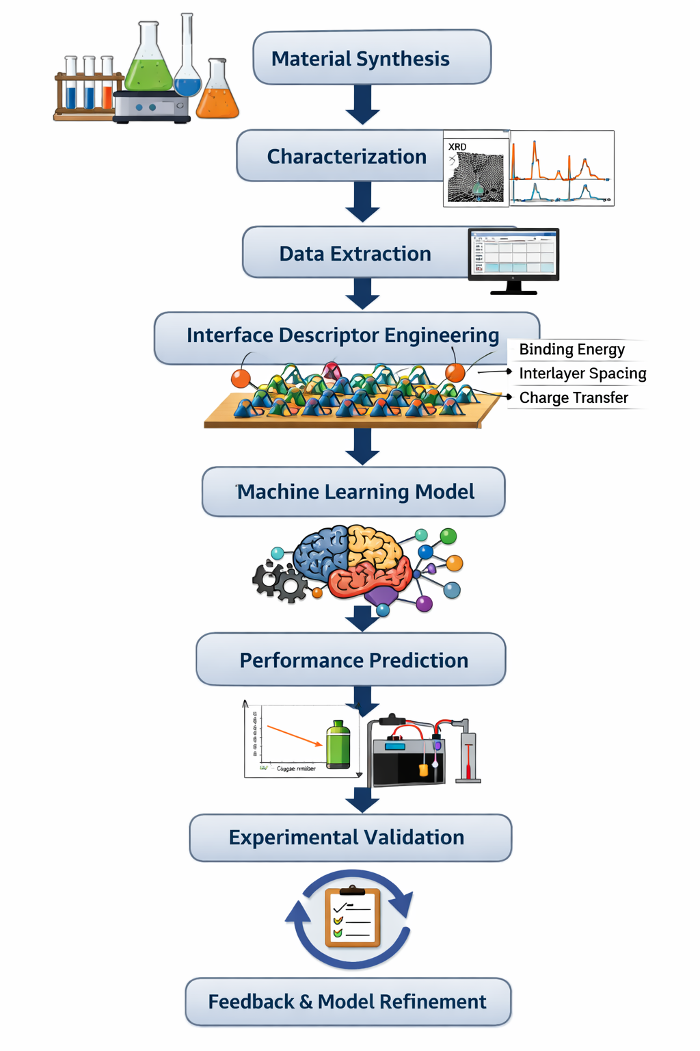
Methodology |  | The project combines experimental materials science with machine learning to predict electrochemical performance of MoO₃-based heterostructures, focusing on interfacial features that influence device behavior. The methodology is divided into the following steps:  1. Material Synthesis  - Synthesize MoO₃-based heterostructures with various compositional and structural modifications (e.g., MoO₃/MoS₂, MoO₃/carbon composites).  - Control particle size, morphology, and surface properties using techniques such as hydrothermal synthesis, sol-gel methods, or chemical vapor deposition (CVD).  2. Material Characterization  - Analyze crystal structure and phase composition using X-ray diffraction (XRD).  - Examine surface morphology and interface formation using scanning electron microscopy (SEM) and transmission electron microscopy (TEM).  - Determine chemical composition and oxidation states via X-ray photoelectron spectroscopy (XPS).  - Evaluate porosity and surface area using BET analysis.  3. Electrochemical Testing  - Measure electrochemical performance using techniques such as cyclic voltammetry (CV), galvanostatic charge-discharge (GCD), and electrochemical impedance spectroscopy (EIS).  - Record key metrics: specific capacity, rate capability, cycle stability, and interfacial kinetics.  4. Interface Descriptor Engineering  - Extract quantitative descriptors representing the interface properties of heterostructures (e.g., surface energy, defect density, heterojunction alignment, electronic conductivity).  - Correlate these descriptors with measured electrochemical performance to identify critical factors governing device behavior.  5. Machine Learning Model Development  - Construct an interface-sensitive machine learning model (e.g., Random Forest, Gradient Boosting, or Neural Networks).  - Use the experimental dataset (materials descriptors + electrochemical performance) for model training, validation, and testing.  - Optimize hyperparameters and evaluate model performance using metrics such as R², RMSE, and MAE.  6. Performance Prediction and Experimental Validation  - Use the trained model to predict performance of untested heterostructure compositions or interface designs.  - Experimentally synthesize top-performing predicted structures and validate their electrochemical behavior.  - Feed results back into the model for iterative improvement (active learning loop).  7. Data Analysis and Model Refinement  - Identify trends and correlations between interfacial descriptors and electrochemical metrics.  - Refine the ML model for higher prediction accuracy and generalizability.  - Develop design guidelines for high-performance MoO₃-based heterostructures.
System Requirement Specifications  - Hardware Requirements  - Software Requirement |  | Hardware:  - High-performance computer (16 GB RAM, GPU preferred)  - Electrochemical workstation  - Characterization instruments (XRD, SEM, TEM, XPS)  Software:  - Python + ML libraries  - Electrochemical analysis software  - DFT tools (optional)
Applications of the Project |  | - High-performance lithium-ion batteries  - AI-driven material discovery  - Interface engineering of heterostructures  - Industrial battery optimization  - Renewable energy storage systems
Conclusion |  | This project aims to establish a predictive framework that combines experimental materials science with machine learning to accelerate the development of high-performance MoO₃-based heterostructures. By systematically integrating material synthesis, interface descriptor engineering, and advanced machine learning models, the proposed system will enable accurate prediction of electrochemical properties, reducing trial-and-error experimentation. The anticipated outcomes include identification of key interfacial features governing performance, optimization of heterostructure design, and guidance for experimental validation. Overall, this approach will significantly enhance the efficiency of developing next-generation electrode materials for energy storage applications and contribute to advancing data-driven materials research.
References:  (IEEE format) |  | - Z. Wei, Q. He, and Y. Zhao, “Machine learning for battery research,” J. Power Sources, vol. 549, p. 232125, Nov. 2022, doi: 10.1016/j.jpowsour.2022.232125.  - T. Sun, Z. Wang, L. Zeng, and G. Feng, “Identifying MOFs for electrochemical energy storage via density functional theory and machine learning,” npj Comput. Mater., vol. 11, Art. no. 90, Apr. 2025.  - S. Chen et al., “Machine learning-guided construction of MoS₂/MoO₃ heterostructures on hollow carbon shells for polysulfide mitigation in lithium-sulfur batteries,” J. Colloid Interface Sci., vol. 702, pt. 1, p. 138830, Jan. 2026, doi: 10.1016/j.jcis.2025.138830.  - H. Zhang et al., “Phase-engineered MoO₃/MoO₂ heterostructures for enhanced Zn²⁺/H⁺ pseudocapacitive storage in aqueous zinc-ion batteries,” J. Colloid Interface Sci., vol. 700, pt. 1, p. 138377, Dec. 2025, doi: 10.1016/j.jcis.2025.138377.  - M. Periyasamy et al., “Tailoring the electrochemical performance of MoO₃ nanocomposites with MWCNTs and rGO for high-performance supercapacitors,” Sci. Rep., vol. 16, Art. no. 214, Jan. 2026, doi: 10.1038/s41598-025-32926-7.  - • J. Ding et al., “Fe₂O₃/MoO₃@NG heterostructure enables high pseudocapacitance and fast electrochemical reaction kinetics for lithium-ion batteries,” ACS Appl. Mater. Interfaces, vol. 14, no. 33, pp. 37747-37758, Aug. 2022, doi: 10.1021/acsami.2c09082.
Mention any two SDG goals that are mapped with this  project |  | 1. SDG 7 – Affordable and Clean Energy  Key Indicators:  - 7.2.1 – Renewable energy share in the total final energy consumption  Relevance: Improved battery and energy storage materials enable higher adoption of renewable energy by stabilizing supply and enhancing efficiency.  - 7.3.1 – Energy intensity measured in terms of primary energy and GDP  Relevance: Developing high-performance electrodes reduces energy losses in storage systems, improving overall energy efficiency.  2. SDG 9 – Industry, Innovation, and Infrastructure  Key Indicators:  - 9.5.1 – Research and development expenditure as a proportion of GDP  Relevance: This project contributes to scientific innovation in materials and machine learning, aligning with investment in R&D.  - 9.5.2 – Researchers per million inhabitants  Relevance: Training and involvement of researchers in cutting-edge energy materials and computational modeling supports capacity building in advanced technologies.
 | Signature of Guide Signature of Divsion Head Signature of HOD

